View Menu

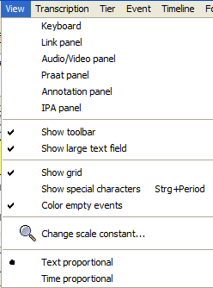

View > Keyboard
Defines, whether the keyboard is shown or hidden (virtual keyboard, see also section III "Panels“) . The keyboard can also be hidden by using the x in the top right corner of the keyboard window.

View > Link panel
Defines, whether the panel for creating links is shown or hidden (link tool). The link panel can also be hidden by using the x in the top right corner of the link panel window.

View > Audio/Video panel
Defines, whether the panel for playing audio and video files is shown or hidden. (audio/video tool, see also section VI. "Panels“) The audio/video panel can also be hidden by using the x in the top right corner of the panel window.

View > Praat panel
Defines, whether the panel for communication with Praat is shown or hidden (Praat tool, see also section III "Panels“). The Praat panel is only available in windows. Therefore, this menu item should not appear when using other systems.

View > Annotation panel
Specifies, whether the Annotation panel (see also section III) is shown or hidden.

View > IPA panel
Specifies, whether the IPA panel (see also section III) is shown or hidden.

View > Show toolbar
Defines, whether the toolbar is shown or hidden.

View > Show large text field
Specifies whether the large text field (for entering and displaying transcription text) is shown or hidden.

View > Show grid
Specifies whether the grid on the musical score is shown or hidden. Using the grid makes it easier to navigate in the musical score and also makes the division of events more clear:

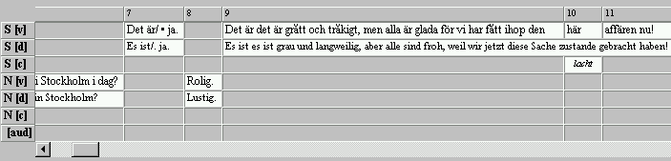

Hidden grid lines hide the table-like structure of the user interface. This makes the user interface look more like a "musical score", especially if the background colour of blank events is set to “white“ (see also "Format Menu“ and "View Menu“):

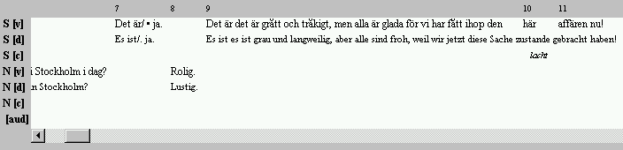

View > Show special characters
Shows spaces in the musical score as little dots (similar to MS Word). For this, the musical score has to be reformatted. This may take a few seconds. Please note: If this option is activated, the musical score can not be edited! In order to be able to edit again, deactivate this option by selecting the function from the menu or the toolbar once more.

Standard View  (musical score can be edited): | "Show special characters“ activated  (musical score can not be edited):
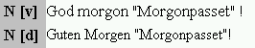 | 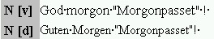

View > Color empty events
Defines, whether the blank spaces in the transcription that do not contain an event should have a coloured tint when viewed on the screen. The colour will not be included in the output. The shading colour is preset to "grey“ and can be changed by using Format > Edit format table. In the dialogue, go to „EMPTY-EDITOR“ and then click the Edit button beside the entry "Background color“, in order to pick your colour.

The calculation of the coloured shading is time consuming. Therefore it is advisable to deactivated this option for larger transcriptions, as this will make the editor work significantly faster.

Option „Color empty events“ deactivated: | Option „Color empty events“ activated:
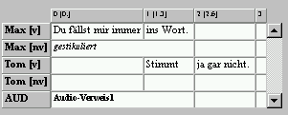 | 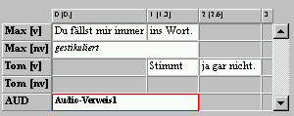

View > Change scale constant…
Opens a dialogue to change the scale constant.

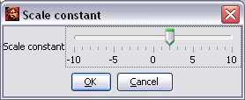

The scale constant is the value that is added to the set point size of the fonts for the display in the editor. A scale constant of +5 will display a text which is formatted as 10 pt, with a font size of 15 pt. Use the slider in order to change the scale constant and click OK. The musical score has to be reformatted afterwards. This may take a few seconds.

Note: The font size in the text box above the musical score can be changed by using the slider at the right margin of the box:

View > Text proportional / Time proportional

In normal view, the width of "cells" within the musical score is calculated according to the width of the text inside them ("text proportional“). When switching to the "time proportional“ view, the width is calculated according to the length of time of the interval. Furthermore, the oscillogram and the musical score are synchronised. This is equivalent to the view of tools like ANVIL, ELAN or Praat.

Text proportional view:

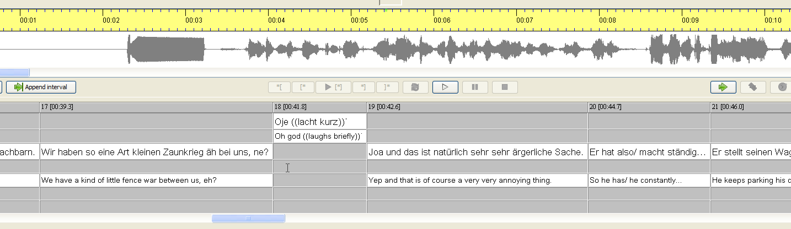

Time proportional view:

